Returning to Work After COVID-19 Isolation

  - While work restrictions may be lifting, the hazards related to the COVID-19 virus remain a significant health risk. As businesses start to resume operations, we encourage you to consider these best practices to protect employees and visitors to your workplace.
We recommend bringing employees back in phases, starting with a restrictive environment and moving to a more integrated environment with few long-term changes to our work environments in the final phase. Each phase of this guidance addresses those aspects of life for which restrictions remain appropriate due to COVID.

Employees who should be considered for reintroduction into the workplace would include:
- Working from home consistently would not be feasible for job duties;
- Personnel are asymptomatic;
- Personnel shelter in place when not at work;
- Personnel undergo temperature monitoring and symptom checks upon arrival to work and at least every 12 hours while at work, and self-monitor (i.e. take temperature, assess for symptoms) twice a day when at home;
- Personnel required to interact with individuals within 6 feet should wear a facemask while working for 14 days following the last exposure;
- Personnel whose job duties permit a separation of greater than 6 feet should have environmental controls in place to ensure adequate separation is maintained, and do not need to wear a facemask;
- If personnel develop symptoms consistent with COVID-19 (e.g., fever, cough, or shortness of breath) while working, they should immediately stop work and isolate at home;
- Any testing should be prioritized for essential personnel with symptoms;
- Consider special accommodations for personnel who are members of a vulnerable population

Office controls
- Establish a Pandemic Team Leader
- Place posters around your building that support staying home when sick, how to cough and sneeze, and keeping hands clean. Put them up in places where people will see them.
- Make sure you have tissues and no touch trash cans throughout the building.
- Define protocols and a room/space within your office where a visitor or employee can be effectively isolated temporarily if deemed to be symptomatic.
- Maintain a 30 -day supply of disposable gloves, medical masks, hand soap, and hand sanitizer.
- Provide gloves when staff clean and check rooms and any areas people have access to.
- Close lunch rooms and limit access to bathrooms and areas where people gather.
- Set up work areas so that employees can maintain at least 6 feet distance from each other.
- Eliminate dense population of employees.
  - Consider staggered shifts or assigning employees specific hours/days of the week
- Ensure hand hygiene supplies are readily available in building.
- Increase the percentage of outdoor air that circulates into the system.
- Provide soap and water in the workplace. If soap and water are not readily available, use alcohol-based hand sanitizer that is at least 60% alcohol. If hands are visibly dirty, soap and water should be chosen over hand sanitizer. Ensure that adequate supplies are maintained.
- Place hand sanitizers in multiple locations to encourage hand hygiene.
- Provide disposable wipes so that commonly used surfaces (for example, doorknobs, keyboards, remote controls, desks, other work tools and equipment) can be wiped down by employees before each use. To disinfect, use products that meet EPA’s criteria for use against SARS-Cov-2external icon

Employee/ Visitor Screening
Screen everyone who enters your facility, including:
• All employees before the start of each work shift
• All visitors
Ask the following questions when you screen employees and visitors: YES or NO, since your last day of work, or since your last visit to this facility, have you had any of the following:”
- A new fever (100.4°F or higher), or a sense of having a fever?
- A new cough that you cannot attribute to another health condition?
- New shortness of breath that you cannot attribute to another health condition?
- A new sore throat that you cannot attribute to another health condition?
- New muscle aches (myalgias) that you cannot attribute to another health condition, or that may have been caused by a specific activity (such as physical exercise)?
If an employee or visitor answers YES to any of the screening questions, emergency protocols should be activated including;
- Exclusion of the employee or visitor from the facility, immediately sent home
- Providing a medical mask or face shield

Work practices: Creating Social Distancing

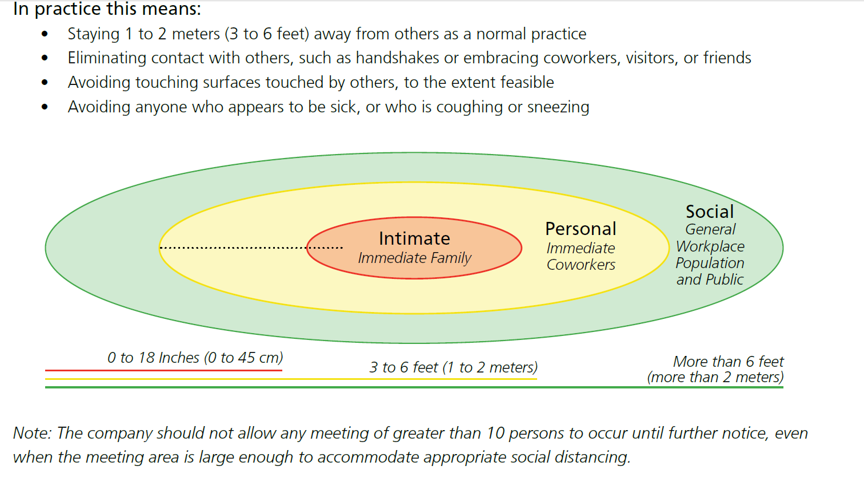
- Discourage communal transportation
- Continue to encourage telework
- Consider alternate team approaches for work schedules
- Consider Communal Bathroom usage during the work day
- Do not have in-person meetings.
- If you must have an in-person meeting, meet in a large room and be at least 6 feet from one another. Meet for as short as you can.
- Limit visitors.
- Have everyone wash their hands with soap and water for at least 20 seconds. If soap and water are not around, clean hands with a hand gel that has at least 60% alcohol in it. Make sure these supplies are always around and in multiple locations.
- Carefully consider whether travel is necessary.
- Consider canceling, adjusting, or postponing large work-related meetings or gatherings that can only occur in-person.
- Employees should wash their hands for 20 seconds after receiving deliveries or packages

Cleaning & Disinfection
- Clean and disinfect all work space areas, breakrooms, bathrooms, conference rooms, common areas before allowing employees to return to work
- Routinely clean and disinfect all frequently touched surfaces in the workplace, such as workstations, keyboards, telephones, handrails, and doorknobs.
- If surfaces are dirty, they should be cleaned using a detergent or soap and water prior to disinfection. For disinfection, most common EPA-registered household disinfectants should be effective. A list of products that are EPA-approved for use against the virus that causes COVID-19 is available here pdf iconexternal icon. Follow the manufacturer’s instructions for all cleaning and disinfection products (e.g., concentration, application method and contact time, etc.).
- Provide cleaning wipes so that high touch objects (for example, doorknobs, remote controls, keycards) can be wiped down before each use.
- Prepare for deep cleaning after a confirmation of a positive test, this should be performed by an approved external company. ( www.epa.gov)

Employee Training
Pre -return to work (Topics to include Personal Hygiene Tips, Social Distancing, Sanitization & Disinfection, Self-Screening)
- Educate employees not to touch their eyes, nose, and mouth with unwashed hands.
- Encourage personal protective measures among staff (e.g., stay home when sick, hand-washing, respiratory etiquette).
- Discourage handshaking – encourage the use of other noncontact methods of greeting.
- Direct employees to visit the coughing and sneezing etiquette and clean hands webpage for more information.
- Discourage workers from using other workers’ phones, desks, offices, or other work tools and equipment, when possible. If necessary, clean and disinfect them before and after use.

- Daily self-screening; How to assess for symptoms (fever, cough, or shortness of breath) and take temperature twice a day when at home;

Phase 2 (tied to availability of COVID testing)- Review Workplace Policies and Essential Travel

- Continue to conduct Employee Training; Topics to include Personal Hygiene Tips, Social Distancing, Sanitization & Disinfection, Self-Screening as more employees return to work
- Review office population and travel policies
- Re-open break rooms, conference/training rooms but restrict access by department
- Allow in-person meetings while maintaining established social distancing protocols

- Advise employees before traveling to take additional preparations:
- Check the CDC’s Traveler’s Health Notices for the latest guidance and recommendations for each country to which you will travel. Specific travel information for travelers going to and returning from countries with travel advisories, and information for aircrew, can be found on the CDC website.
- Advise employees to check themselves for symptoms of COVID-19 (i.e., fever, cough, or shortness of breath) before starting travel and notify their supervisor and stay home if they are sick.
- Ensure employees who become sick while traveling or on temporary assignment understand that they should notify their supervisor and promptly call a healthcare provider for advice if needed.
- If outside the United States, sick employees should follow company policy for obtaining medical care or contact a healthcare provider or overseas medical assistance company to assist them with finding an appropriate healthcare provider in that country. A U.S. consular officer can help locate healthcare services. However, U.S. embassies, consulates, and military facilities do not have the legal authority, capability, and resources to evacuate or give medicines, vaccines, or medical care to private U.S. citizens overseas.

Phase 3- Getting back to normal
- Continue to conduct Employee Training; Topics to include Personal Hygiene Tips, Social Distancing, Sanitization & Disinfection, Self-Screening
- Review office and travel policies
- Resume unrestricted staffing
  - Consider enhanced controls for known vulnerable employees

